Proposal

For

Hispanic Students Perceptions of Online Learning Courses

at a Hispanic Serving Institution Community College

by

Shari Carrasco Rodriquez

Submitted to

Matthew A. Eichler, PhD

Occupational Education

Texas State University

in Partial Fulfillment of the Requirement for

OCED 5300

Fall 2010

Abstract

*Purpose*

Colleges and universities have experienced higher than average enrollment growth as a result of the recent economic downturn. Community colleges in particular have higher than average enrollment increases due to their open-door admissions policies. Their student population tends to be demographically diverse and one that desires flexibility to accompany their educational goals.

Many policy makers and educational administrators are looking to ways to solve this exponential student growth. The immediate response is to increase distance learning courses. Distance learning courses can accommodate more students, use less faculty, and little to no classroom space.

A study conducted by the U.S. General Accounting Office identified what can potentially be a problem at community colleges with high Hispanic student enrollment. This study reported that Hispanic students are less likely to enroll in distance learning courses or incorporate them into their curriculum.

The researcher has identified a metropolitan community college in Austin, Texas that has recently been deemed eligible for a Hispanic Institution Status by the U.S. Department of Education. This college is comprised of students enrolled from eight surrounding counties.

*Procedures*

This study will examine perceptions of online courses and perceptions of learning styles of students at a HSI metropolitan community college and deduce through disaggregated data if empirical findings concur with the United States General Accounting Office report of 2002. The research study will be non-experimental and will administered via web-based questionnaire and using a traditional non-electronic paper form. The following questions will be addressed: 1) What are students’ perceptions of online learning at a HSI metropolitan community college, 2) What are students’ perceptions of learning styles at a HSI metropolitan community college, and 3) Does ethnicity play a role in students’ perceptions of online learning.

*Significance*

The U.S. General Accounting Office identified what can potentially be a problem at Austin Community College if in fact; Hispanic students are less likely to incorporate distance learning into their curriculum. With limited data, it is difficult to identify causes of Hispanic students’ resistance to distance learning. The projected population growth of Hispanics and their current educational attainment levels signal the need to pay more attention to this group in higher education (Bailey, Thomas R. and Alfonso, Mariana , 2005). The researcher hopes to explore this issue so that the college may use this data to augment future studies addressing students’ perceptions of online learning.

Table of Contents

|  |  |
| --- | --- |
| Abstract | 2 |
| Purpose | 2 |
| Procedures | 2 |
| Significance | 3 |
| Table of Contents | 4 |
| Chapter I | 7 |
| Statement of the Problem | 7 |
| Purpose | 9 |
| Objectives | 10 |
| Assumptions and Limitations | 12 |
| Relationship to Academic Program and Experience | 13 |
| Chapter II – Review of the Literature | 15 |
| Review of Related Literature | 15 |
| Need for Further Research | 23 |
| Research Question | 23 |
| Chapter III – Methodology and Procedures | 24 |
| Overview | 24 |
| Population and Sample | 24 |
| Variables/Constructs | 25 |
| Instrumentation | 26 |
| Data Collection Process | 26 |
| Data Analysis Process | 27 |
| Expected Presentation of Research Results | 28 |
| Procedures for Semester 1 (OCED 5301) | 29 |
| Pre-contractual Activities | 29 |
| Contractual Activities | 29 |
| Post-contractual Activities | 30 |
| Start Date and Duration per Activity (Chart) | 31 |
| Procedures for Semester 2 (OCED 5302) | 32 |
| Pre-contractual Activities | 32 |
| Contractual Activities | 32 |
| Post-contractual Activities | 34 |
| Start Date and Duration per Activity (Chart) | 34 |
| Chapter IV – Research Evaluation Plan | 36 |
| Formative Evaluation | 36 |
| Procedures to be Evaluated | 36 |
| Evaluation Parameters (Time and Quality) | 37 |
| Weight | 37 |
| Summative Evaluation | 37 |
| Products to be Evaluated | 37 |
| Evaluation Parameters | 38 |
| Weight | 38 |
| Independent Evaluator | 38 |
| References | 40 |
| Appendix | 43 |
| Research Contract I | 45 |
| Research Contract II | 48 |
| Formative Evaluation Forms | 51 |
| Summative Evaluation Forms | 59 |
| Instrumentation | 64 |
| Agency Approval | 67 |
| IRB Certification Completion Certificate | 68 |
| Proposal Evaluation | 70 |

Chapter I

## *Statement of the Problem*

Colleges and universities have experienced higher than average enrollment growth as a result of the recent economic downturn. Institutions of higher education are responding swiftly to identify appropriate course delivery methods as a result of increased enrollment. Community college are particularly experiencing higher than average enrollment increases because of their open-door admissions policies, flexibility, and comparatively affordable tuition. Community colleges have always attracted students that are demographically diverse. However, coupled with astronomical enrollment growth, budget cuts, and limited space, policy makers and administrators of the like are relying on instructional methods such as distance learning to resolve such issues and bridge educational gaps.

Many studies discuss outcomes of distance learning courses as it applies to *all* students with positive and negative outcomes. Yet, a large majority of research on program effectiveness in higher education is limited to studies of four-year colleges. Insights obtained from this type of research do not necessarily translate to effective practices for the part-time, working, and adult population that characterizes community college students (Bailey, Thomas R. and Alfonso, Mariana , 2005).

Furthermore, the Hispanic population continues to rise and colleges like Austin Community College (ACC) in Austin, TX are fast becoming eligible for Hispanic Serving Institutions (HSI) status. As a result, ACC has met the criterion established by the Department of Education for HSI eligibility. In part, this includes at least twenty-five percent, undergraduate, full-time equivalent Hispanic enrollment. With an HSI designation, the college will be eligible to apply for Title V funds (USDOE, U.S. Department of Education, 2010), and may offset the college’s budget shortfall.

Given the aforementioned, a logical resolve to accommodate the student growth is to offer distance learning courses. In fact, in 2006, the National Center for Education Statistics reported that 97 percent of public 2-year Title IV degree-granting postsecondary institutions offered *any* online, hybrid/blended online or other distance education courses (Basmat, B. and Lewis, L., 2008). In fall 2010, online learning at Austin Community College accounted for 12.2 percent of enrollments and 10.4 percent of sections (OIEA, Office of Institutional Effectiveness and Accountability, 2010).

Herein suggests a problem; on September 26, 2002, the United State General Accounting Office (U.S. GAO) released a written testimony to be presented before the U.S. Senate Committee on Health, Education, Labor, and Pensions; distance education continues to grow and as such, regulations may need to be reexamined as they pertain to distance education. The testimony posits that in general, students at minority serving institutions use distance education less extensively than students at other schools. Moreover, undergraduate Hispanic students attending HSI’s use distance education less often than other students at these institutions (GAO, U.S. General Accounting Office, 2002).

The U.S. General Accounting Office identified what can potentially be a problem at Austin Community College if in fact; Hispanic students are less likely to incorporate distance learning into their curriculum. With limited data, it is difficult to identify causes of Hispanic students’ resistance to distance learning. Furthermore, the relationship between online learning and learning styles of individuals who enroll in online courses has received little attention (R.N. Harris, 2003).

*Purpose*

The purpose of this study is to explore the notion that Hispanic students are less likely to incorporate distance learning into their curriculum. Austin Community College offers five varieties of distance learning courses to include: online courses, hybrid courses, instructional television, print-based course, and directed studies. This study will examine perceptions of online courses and perceptions of learning styles of students at a HSI metropolitan community college and deduce through disaggregated data if empirical findings concur with the United States General Accounting Office report of 2002. As students become more experienced with online instruction, their attitudes towards e-learning and blended approaches may change (Smart, 2006 , p. 215).

The research design will be non-experimental and will use descriptive questions to be administered via a web-based survey and made available using a traditional non-electronic form. The researcher has identified three questions for this study: 1) What are students’ perceptions of online learning at a HSI metropolitan community college, 2) What are students’ perceptions of learning styles at a HSI metropolitan community college, and 3) Does ethnicity play a role in students’ perceptions of online learning.

The population for this study will be comprised of students enrolled at Austin Community College (ACC), Austin, TX. ACC is comprised of eight counties; Gillespie, Blan­co, Hays, Travis, Caldwell and Bastrop, plus por­tions of Williamson and Gonzales Counties. ACC offers vocational and technical programs of varying lengths leading to certificates or degrees. Freshman and sophomore academic courses leading to an associate degree or to transfer to a four-your institution are also offered. Additionally, ACC offers courses in continuing adult education for academic, occupational, professional, and cultural enhancement.

According to the Office of Institutional Effectiveness and Accountability at Austin Community College (ACC), the fall 2010 unduplicated headcount was 44,100. This is an overall increase of 9.6 percent over fall 2009 (40,248) (OIEA, Office of Institutional Effectiveness and Accountability, 2010). In general, the students that account for the current enrollment growth are generally ethnically diverse and are comprised of working professionals, single parents, adult learners, and displaced workers.

## *Objectives*

1. Identify a sample of students from a metropolitan community college in Austin, TX that is representative of Hispanic students in spring, 2011.

1. a. Determine the minimum sample size needed based on a confidence level and interval level.

1. b. Identify students to participate in survey.

1. Develop and prepare survey questionnaire

2. a. Identify how students will find out about the survey.

2. b. Obtain permission from student groups to post survey information.

2. c. Identify a student event on campus.

2. d. Obtain permission to host the survey link from a college affiliated association.

2. e. Secure approval offer nominal cash incentive for participation.

2. f. Secure survey monkey web-based survey.

2. g. Make paper copies available.

2. h. Design questionnaire

2. i. Pretest questionnaire

2. j. Administer survey

2. k. Use convenience sampling method

1. Collect student data

3. a. Identify students’ response to perceptions of online learning

3. b. Identify students’ responses to perceptions of learning style

3. c. Identify student demographics

3. d. Use descriptive analysis

3. e. Use Microsoft Excel to clean data

3. f. Use SPSS to conduct statistical analysis

1. Analyze data

4. a. Use descriptive analysis

4. b. Identify outliers

4. c. Clean data for consistency

4. d. Identify if questions were all answered.

4. e. Examine data by using univariate analysis

4. f. Solve for distribution

4. g. Calculate central tendency

4. h. Identify dispersion

4. i. Create frequency distribution table

4. j. Identify mean, median, and mode.

4. k. Calculate standard deviation

4. l. Calculate variance by using ANOVA model

4. m. Calculate multiple regression and correlation

4. n. Use The Person r

4. o. Chi-square test of independence

1. Document Research

5. a. State the research problem

5. b. State causal relationship

5. c. State constructs

5. d. Cite literature from scholarly journals and other credible sources.

5. e. State research questions

5. f. Discuss sampling procedures

5. g. Discuss external validity considerations

5. h. Evaluate outcome measures

5. i. Discuss construction measures

5. j. Address reliability and validity

5. k. Write results with tables or figures

## *Assumptions and Limitations*

The research has the following assumptions:

1. Hispanic student enrollment in distance learning course is not equivalent to non-Hispanic students at Title V institutions.

This research has the following limitations:

1. The data collected will be representative of one metropolitan community college in Texas.

## *Relationship to Academic Program and Experience*

The validity of learning styles in higher education seems to be an emergent topic for consideration. As educators are looking for ways to merge technology and instruction, theories of learning styles are quickly debated. Debated by whom? Are policy makers and educational administrators more likely to take an oppositional stance towards learning style models? What do the learners have to say about this? Personally, I have always struggled with academics, and my son has experienced the same concerns that I had and still have as a learner. So, I believe there has to be merit in teaching methods for various learners. To assume that a one size fits all model of instruction should be applied to all learners is unfathomable.

I chose occupational education as my area of emphasis for my masters program because I find it a unique blend of my current professional experience. Having over fifteen years of human resources experience, and over five of those years in higher education; I am privileged to have such a breadth of experience. My coursework in Occupational Education lends itself to both human resources and education, more specifically my current field of post-secondary education.

This particular study on Perceptions of Learning Styles transcends K-16 students; this concept should be applied to all learners. Another group of learners are employees—all employees currently in the workforce. As employers encourage professional development and life-long learning, attention should be paid to content delivery. Just because students matriculate through college and to the workforce, this does not mean that their learning style has changed. They may, however; be more aware of what kind of learning environment is most suitable for their professional success. The challenge is to educate employers to accommodate and appreciate different learning styles in their employees.

My long-term goal is to pursue a PhD and contribute to employees’ success in organizations. With a new generation of employees entering the workforce, it is imperative that organizations understand how the science of human performance can be productive or destructive to their bottom line.

Chapter II – Review of the Literature

## *Review of Related Literature*

Introduction

Delivery mechanisms of online courses are substantially different from traditional face-to-face courses. Common sense might suggest that attitudes and perceptions by students are integral to the success or failure of online courses. Thus, insights about attitudes and perceptions of online learning may be useful to colleges as they endeavor to design and deploy online courses at their institutions (Bathe, 2001). Perceptions can be derived from the environment we grow up in and can be influenced by how one thinks, acts, communicates, and relates to others. Learning preferences may also be a perception that a learner holds factor in overall perceptions of online courses or learning style preferences. The researcher assumes the reader has general knowledge of perspectives and learning styles as it applies to “learning”. However, *Appendix* A identifies most cited learning style modules in academic journals today. The researcher will not expound on such controversies, nor compare or contract models of learning styles, rather reference learning style models as appropriate for the literature review.

As technologies continue to evolve, a pedagogical framework that considers the learning environment differences between traditional and face- to-face classes becomes increasing imperative, both in terms of understanding the delivery and mediation of instruction (Beebe, Vonderwell, & and Boboc, 2009, p. 1). Individuals collaboratively construct a common grounding of beliefs, meanings, and understandings that they share in activity through a community of learning or practice. These perceptions depend largely on socio-cultural and communicative context for their development.

The USDOE conducted a meta-analysis and review of online learning studies, the methodology and results of this study will provide a general framework for understanding the crux of online learning in higher education today, more specifically to a metropolitan community college in Texas. The literature review will include students’ perceptions of online learning, perceptions of learning styles, and discuss persistence in online instruction.

**Online Learning**

Research for this proposal will concentrate on online learning; asynchronous and synchronous, as defined by the U.S. Department of Education (USDOE). An asynchronous model uses communication tools such as: e-mail, threaded discussion boards, and newsgroups. This method allows users to contribute at their convenience. In a synchronous model, technologies such as: webcasting, chat rooms, and desktop audio/video technology are used to approximate face-to-face teaching strategies such as delivering lectures and holding meetings with groups of students (U.S. Department of Education, Office of Planning, Evaluation, and Policy Development: Policy and Program Studies Service, 2009, p. 1).

Online learning overlaps with the broader definition of distance learning, which encompasses earlier technologies such as correspondence courses, educational television, and videoconferencing. The tradition of distance education goes back at least 100 years to the early correspondence course (U.S. Department of Education, Office of Planning, Evaluation, and Policy Development: Policy and Program Studies Service, 2009, p. 1). Earlier studies of distance learning concluded that these technologies were not significantly different from regular classroom learning in terms of effectiveness. Policy makers reasoned that if online instruction is no worse than traditional instruction in terms of students outcomes, then online education initiatives could be justified on the basis of cost efficiency or need to provide access to learners in settings where face-to-face instruction is not feasible (U.S. Department of Education, Office of Planning, Evaluation, and Policy Development: Policy and Program Studies Service, 2009, p. xi).

**Perceptions**

Students’ perceptions of online learning are evolving parallel to technological advances in online course delivery and content. Often times, negative student perceptions of online learning are the result of distance learning options of the past. The tradition of distance education goes back at least 100 years to the early correspondence course (U.S. Department of Education, Office of Planning, Evaluation, and Policy Development: Policy and Program Studies Service, 2009, p. 1).

A longitudinal case study conducted by Stewart Adam and Deon Nel of Deakin University in Melbourne, Australia sought to identify students’ perceptions of online and blended courses as tool to improve educator knowledge of the antecedents and consequences of blended learning in higher education (Adam, 2009, p. 140). The longitudinal case study included three case studies each involving tracking student evaluations of teaching (SET) measure and grade point average over six years. Over this period, three subjects from the same business discipline were studied. Students involved in this study included those living on and off campus at Deakin University. The variables for this study were the business subjects taught solely online, a business subject where face-to-face teaching was primarily used and a business subject where online content supplemented the learners’ experiences (Adam, 2009, p. 140). Case study is an online study, case study two involves the use of blended learning, and case study three involves a more traditional face-to-face approach.

The first case study collected data from students enrolled in an online Marketing I course. The course textbook was provided online as well as other audio-visual aids that augmented the textbook. This subject was the first course offered as an online course and overtime, the SET scores eventually decreased despite high online student interaction. Many students perceived that total dependency on knowledge media coupled with online discussion and interaction via a computer-mediated medium did not fully meet their educational needs (Adam, 2009, p. 148)

The subject of the second case study was Direct and Online Marketing based on face-to-face teaching methods and knowledge media such as: Blackboard, emails, and online discussions. At one point in the study, pre-recorded lectures on CD-ROM were used and later outsourced due to instructor unavailability. Specially recorded podcasts were introduced to this course and students were able to see lectures via podcasts along with journal readings. Students attended four workshops within the semester rather than traditional face-to-face lectures. This blended approach to learning condensed lectures and offered a more tailored approach which was helpful in facilitating online discussions.

Strategic marketing, the third case study entailed blended learning, face-to-face, and online content delivery. This course was used with similar learning tools such as a CD-ROM, Blackboard, and online discussion groups. Additionally, smaller face-to-face tutorials were added and used to discuss the subject in greater detail. Student discussions were encouraged by weekly topic discussions, face-to-face discussions, and on-campus discussions using recorded mp3 tutorials. In all three case studies students reflected on the information and content covered during the learning process (Adam, 2009, p. 151).

The findings conclude that student perceptions indicated that they favored a blended learning approach that while it involved face-to-face teaching, it also incorporated knowledge media and used a live Navigator (Adam, 2009, p. 154). Adam and Nel also note that an opportunity for higher education institutions to develop models of teaching deliver modes that better accommodate student cultural diversity exists.

**Learning Styles**

Educators have long known that students prefer a certain method of learning. Knowledge of student learning preferences can aid faculty in class preparation, designing class delivery methods, choosing appropriate technologies, and developing sensitivity to differing student learning preferences within the online learning environment. Issues associated with how students learn online, learner style preferences, and strategies may be related to effective student engagement with online learning (Smith, 2005, p. 3). Online courses should consider instructional strategies that facilitate adult learning to change learners’ perceptions of online learning, and assist them to learn in a more collaborative, authentic and responsible way (Ruey, 2010, p. 706). Online learning has been challenging to all stakeholders and there is also scholarly debate on the validity of learning styles. The researcher will not expound on such controversies, nor compare or contract models of learning styles, rather reference learning style models as appropriate for the literature review. Table 1 shows a summary of learning style models often used in scholarly journals as described by Malcolm S. Knowles, author of The Adult Learner (Knowles & Holton III, 1998, p. 163).

A recent quantitative study on learning styles and computer skills of adult students’ online was conducted to examine the influences of individual learning styles/preferences and prior computer skills on adult learners’ knowledge acquisition in an online text-based special education course (Rakap, 2010, p. 108). The sample included forty-six adult learners who enrolled in a web-based special education course. There were three identified research questions for this study: 1) How do individual learning styles/preferences influence adult learners’ knowledge acquisition in an web-based special education course, 2) What is the relationship between adult learners’ computer skills and learning in a web-based special education course, and 3) Is there any difference on student success based on prior experience with web-based courses.

This study was conducted by using a VARK learning style questionnaire. VARK stands for visual (V), aural (A), read/write (R), and kinesthetic (K) learning preferences (Rakap, 2010, p. 109). The origin of the selected learning style model chosen for this study is outside of the United States and is coincidently not included in Table 1. It is possible that the results of the study may show that a learner has a single learning preference known as uni-modal, or more than on learning preference known as multimodal (Rakap, 2010, p. 111).

The results of this study show that instructors teaching online courses may need to become familiar with learning styles and comfortable with a variety of teaching strategies to address the needs of individuals with different learning preferences (Rakap, 2010, p. 113) because a learner’s learning style will affect the knowledge gained from the course.

Persistence

In another study conducted by Denise E. Stanford-Bowers of Wallace Community College titled, *Persistence in Online Classes: a Study of Perceptions among Community College Stakeholders*; she asserts that when differences in perspectives collide in terms of online learning outcomes, students’ persistence issues can result. This study examined the perceptions of online persistence factors and determined which factors were most important as seen by community college administrators, faculty, and students.

The author acknowledges that online courses have increased astronomically within the past decade and agrees that student attrition is a huge issue in online learning courses. Many studies offer proactive measures from learning communities to technology awareness as methods to increase retention in online courses (Stanford-Bowers, 2008, p. 37). The author goes on to say that of the large numbers of students who register for online courses, many end up withdrawing from the course formally, or informally through lack of participation. Emphasis is commonly placed on the use of technology and advances in technology, but less emphasis is placed on course management such as learning style issues, or differences in students, appropriate course selection, and proper training of online faculty and students (Stanford-Bowers, 2008, p. 38).

This study was conducted using a modified Delphi technique. This consensus-reaching process used three separate groups of participants who represented community college administration, faculty, and students. The three different groups were non-interactive and all participants remained anonymous to each other. Thirty-nine volunteers from 10 community colleges met eligibility requirements to participate in this study. The requirements were that a potential faculty or student panelist would have had completed at least one semester of instruction or learning respectively. An administrator had to have oversight of at least one semester of online learning to meet the requirements. The study was conducted over a 6-8 week period from July 2006 through September 2006 through a series of questionnaires via an online survey website (Stanford-Bowers, 2008, p. 42). The study included three rounds of data collection and a resolution round in which panelists were provided the results of Round 3 responses.

The study focused on the following questions: 1) What indicators influence student persistence in a community college online course according to internal stakeholders, and what importance do the stakeholders place on each of the indicators, 2) What are the areas of consensus among the perceptions of the three stakeholder groups by role (administrators, faculty, and students) in identifying indicators that support student persistence?, and 3) What are the areas of difference among the perceptions of the three stakeholder groups by role (administrators, faculty, and students) in identifying indicators that support student persistence? (Stanford-Bowers, 2008, pp. 46-47)

All three groups had different responses to the first question. Administrators and faculty however, shared the idea that responsiveness of instructor, prompt feedback, student-teacher interaction was indicative of students’ ability to persist in online courses. The students perceived that convenience and flexibility was paramount to their online persistence. The second question identified a consensus among all three groups as to their perceptions of student persistence. They all agreed that computer accessibility, clearly-stated requirements, and time management were equally important. Lastly, the third question considered the difference of opinion in perceptions of student persistence. The administrators were concerned with students’ ability to read and comprehend adequately, and the need for well-studied instructors that were technologically savvy. Whereas, faculty emphasized the need for the institution to commit the financial, technological, and personnel resources to maintain a reliable network (Stanford-Bowers, 2008, p. 47). And lastly, students were concerned with adequate technical support when problems arise. Since students enrolled in online courses maintain a flexible schedule, the emphasis is on, “when problems arise”. Students also mentioned a possible need for some type of personal contact with the instructor in an otherwise totally online environment (Stanford-Bowers, 2008, p. 47).

This study asserts that all students enrolled in an online course must be self-disciplined, self-motivated, allow adequate time to complete assignments, accessibility to appropriate technology, and technical skills are all requirements for students to persist in an online course. The point the author makes is, without a full understanding of how varied groups perceive students ability to persist in online course, it is meaningless if the perceptions of persistence do not converge. Stanford-Bowers suggests increased funding for technology, improve technical support, develop training for college personnel to include new and veteran faculty that teach online courses, and establish student support strategies that can enable student learning, success, and persistence.

## *Need for the Research Activity*

The U.S. General Accounting Office identified what can potentially be a problem at Austin Community College if in fact; Hispanic students are less likely to incorporate distance learning into their curriculum. With limited data, it is difficult to identify causes of Hispanic students’ resistance to distance learning. The projected population growth of Hispanics and their current educational attainment levels signal the need to pay more attention to this group in higher education (Bailey, Thomas R. and Alfonso, Mariana , 2005). The researcher hopes to explore this issue so that the college may use this data to augment future studies addressing students’ perceptions of online learning.

*Research Questions / Hypothesis*

The research questions are:

1. What are students’ perceptions of online learning at a HSI metropolitan community college?
2. What are students’ perceptions of learning styles at a HSI metropolitan community college?
3. Does ethnicity play a role in students’ perceptions of online learning?

The researcher will explore if Hispanic students are less likely to incorporate distance learning into their curriculum. If so, explore students’ perceptions of online learning and perceptions of learning styles and determine if empirical findings can be suggested.

Chapter III – Methodology and Procedures

*Overview*

The methodology and procedures for this study will include identifying a sample of community college students to participate in survey. The variables and constructs for this study have been identified and may change upon further review and results of pre-tests. The research design will be a cross sectional, non-experimental study, using a Likert method. Participants will have the option to participate via web-based questionnaire or via paper copy questionnaire. The only difference will be how the survey is submitted once completed.

The researcher has identified three questions for this study: 1) What are students’ perceptions of online learning at a HSI metropolitan community college, 2) What are students’ perceptions of learning styles at a HSI metropolitan community college, and 3) Does ethnicity play a role in students’ perceptions of online learning.

Data will be collected using Survey Monkey and will be entered into Excel and then transferred to SPSS once data has been cleaned. Finally, the researcher will conclude this study with a final report and presentation of research results.

*Population and Sample*

The population for this study will be comprised of students enrolled at Austin Community College in Austin, TX. ACC is comprised of eight counties; Gillespie, Blan­co, Hays, Travis, Caldwell and Bastrop, plus por­tions of Williamson and Gonzales Counties. As of fall 2010, ACC has 44,100 demographically diverse students. The sample size for this study will be 592 students and has been derived by using *Creative Research Systems* Sample Size Calculator (Creative Research Systems , 2007-2010). The measurement corresponding to a given probability is 4, this is the confidence interval. The Confidence level that will be used for this study will be 95%, which will be indicative of the accuracy of the results.

*Variables / Constructs*

The researcher has identified questions that will gather information about the students’ profile. Nominal level of measurement will be used to collect words on the student profile in response to a question where the student is given the option to identify if they have taken any developmental courses or enrolled in an honors program. Ordinal level of measurement will be used to obtain ranking in response to questions such as highest degree obtained and responses to the Likert scale used in this study. Nominal and ordinal data are also defined as categorical when using SPSS, the researcher may use the terms interchangeably. Table 1 shows an example of the variables and constructs that will be used in this study.

|  |  |  |  |  |  |  |  |  |
| --- | --- | --- | --- | --- | --- | --- | --- | --- |
| Table 1 |  |  |  |  |  |  |  |  |
| Variable | | Mean | Std Dev | Minimum | Maximum | N | n | Level of Measurement |
| Q1 | Gender |  |  |  |  |  |  | Ordinal |
| Q2 | Age Range |  |  |  |  |  |  | Ordinal |
| Q3 | Type of Student |  |  |  |  |  |  | Nominal |
| Q4 | Total Credit Hours |  |  |  |  |  |  | Ordinal |
| Q5 | Enrollment Status |  |  |  |  |  |  | Nominal |
| Q6 | GPA |  |  |  |  |  |  | Ordinal |
| Q7 | Highest Academic Credential |  |  |  |  |  |  | Ordinal |
| Q8 | Employment Status |  |  |  |  |  |  | Nominal |
| Q9 | Hours per week worked |  |  |  |  |  |  | Ordinal |
| Q10 | Family Status |  |  |  |  |  |  | Nominal |
| Q11 | Ethnicity |  |  |  |  |  |  | Nominal |
| Q12 | Language Preference |  |  |  |  |  |  | Nominal |
| Q13 | Previous Enrollment in a Online course |  |  |  |  |  |  | Nominal |
| Q14 | Perceptions of Learning Styles |  |  |  |  |  |  | Nominal |
| Q15 | Perceptions of Online Learning |  |  |  |  |  |  | Nominal |

Table 1 serves as a sample and may change after survey instrument has been tested.

*Instrumentation*

A student profile will be part of the survey questionnaire and includes nineteen questions. The survey that will use a Likert scale method currently has 40 questions and may be revised depending on how long the student may take answering the questions. The survey layout will include opening statement, a student profile, body of the survey, and end with a note of gratitude from the researcher. The researcher may also provide as an end-note, where the participant can find the results of the study and the approximate date of completion. The researcher would like to keep the survey concise and easily comprehended by all students and will administer a pre-test to evaluate the survey’s competency and brevity. The researcher may or may not decide to use all of the stated variables, and will decide upon further review with faculty advisor.

*Data Collection Process*

A questionnaire will be available online via Survey Monkey and a paper copy for students that do not have immediate access to the internet. The questionnaires will be presented at college events, hosted on a college affiliated association’s website, announced at various campuses with the corporation of Student Life, ACC’s gateway to students on campuses, and with flyers posted in the student lounge with the web address and contact information of the researcher. The researcher will also consider a survey incentive of a nominal dollar amount to complete the survey. This would remove the anonymity from the participant; however, this would be optional and not necessary to participate in the survey. Student contact information will be required if students are interested in the survey drawing. The survey will be open for two weeks. The online version will terminate upon set time and date, whereas the paper survey will be returned immediately.

*Data Analysis Process*

The data will be collected and the data will be entered into an Excel spreadsheet and will be cleaned to remove any outliers and/or mislabeled values. Once the data has been cleaned, the data will be transferred to SPSS. Categorical level of measurement will be used in SPSS when collecting nominal and ordinal data. The researcher plans to use descriptive data analysis to find relationships between different variables in the data set and inferential statistics to test the hypothesis. The researcher will use univariate analysis to find the distribution of individual values, central tendency of the distribution, and the spread of the values around the central tendency. The Pearson r will be used to indicate the strength and direction of the relationship between Hispanic students and perceptions of online learning courses and perceptions of learning styles.

Finally, inferential statistics will be used to test the hypothesis by using Chi-Square. This is a test of independence and will test the statistical significance of the relationship of the nominal variables. For this study, this will test the significance between Hispanics and non-Hispanics as well as the statistical significance between native Spanish speaking Hispanics and non-native Spanish speaking Hispanics.

*Expected Presentation of Research Results*

The research results will be introduced by stating facts about the study, and the restating the intent of the study, and briefly discuss applicable literature. Based on the findings of the study, the researcher my include a proposed solution or determine a need for further research. This will be supported by the analytical analysis the researcher conducted over the course of this study may include tables, figures, and graphs to augment findings. The following tables are examples of what will be presented in the final research results report:

Table 2

|  |  |  |  |
| --- | --- | --- | --- |
| Example of Frequency Distribution of  Student Demographic Characteristics | | | |
|  | f | % | cum % |
| Ethnicity |  |  |  |
| African Amer. | 20 | 10 | 27.5 |
| Asian | 11 | 5.5 | 17.5 |
| Hispanic | 24 | 12 | 12 |
| White | 145 | 72.5 | 100 |
| Gender |  |  |  |
| Female | 109 | 54.5 | 54.5 |
| Male | 91 | 45.5 | 100 |
| Total | 200 |  |  |

Note: Samples have been adapted from various examples and does not pertain specifically to this variables and constructs of this study.

Table 3

|  |  |  |
| --- | --- | --- |
| Example of Central Tendency | | |
|  | Reading | Writing |
| Mean | 52 | 53 |
| Median | 50 | 54 |
| Mode | 47 | 59 |
| Variance | 104.60 | 89.39 |
| SD | 10.23 | 9.45 |
| r | 0.60 |  |

Note: Samples have been adapted from various examples and does not pertain specifically to this variables and constructs of this study.

*Procedures for Semester 1*

The researcher will identify a sample, create a survey instrument, collect the data, analyze the data and prepare research documentation.

*Pre-contractual.*

1. Submit IRB request
2. Finalizing contract with instructor
3. Have a clear understanding of study

*Contractual*.

1. Identify a sample of students from a metropolitan community college in Austin, TX that is representative of Hispanic students in spring, 2011.

1. a. Determine the minimum sample size needed based on a confidence level and interval level.

1. b. Identify students to participate in survey.

2. Develop and prepare survey questionnaire

2. a. Identify how students will find out about the survey.

2. b. Obtain permission from student groups to post survey information.

2. c. Identify a student event on campus.

2. d. Obtain permission to host the survey link from a college affiliated association.

2. e. Secure approval offer nominal cash incentive for participation.

2. f. Secure survey monkey web-based survey.

2. g. Make paper copies available.

2. h. Design questionnaire

2. i. Pretest questionnaire

2. j. Administer survey

2. k. Use convenience sampling method

3. Collect student data

3. a. Identify students’ response to perceptions of online learning

3. b. Identify students’ responses to perceptions of learning style

3. c. Identify student demographics

3. d. Use categorical analysis

3. e. Use Microsoft Excel to clean data

3. f. Use SPSS to conduct statistical analysis

*Post-contractual*.

1. Attend a graduate forum.
2. Complete formative and summative evaluations.
3. Write final report of research findings.

*Start Date and Duration of Activity.* The following chart indicates the procedure for each week each and an expected start and end time for OCED 5301.

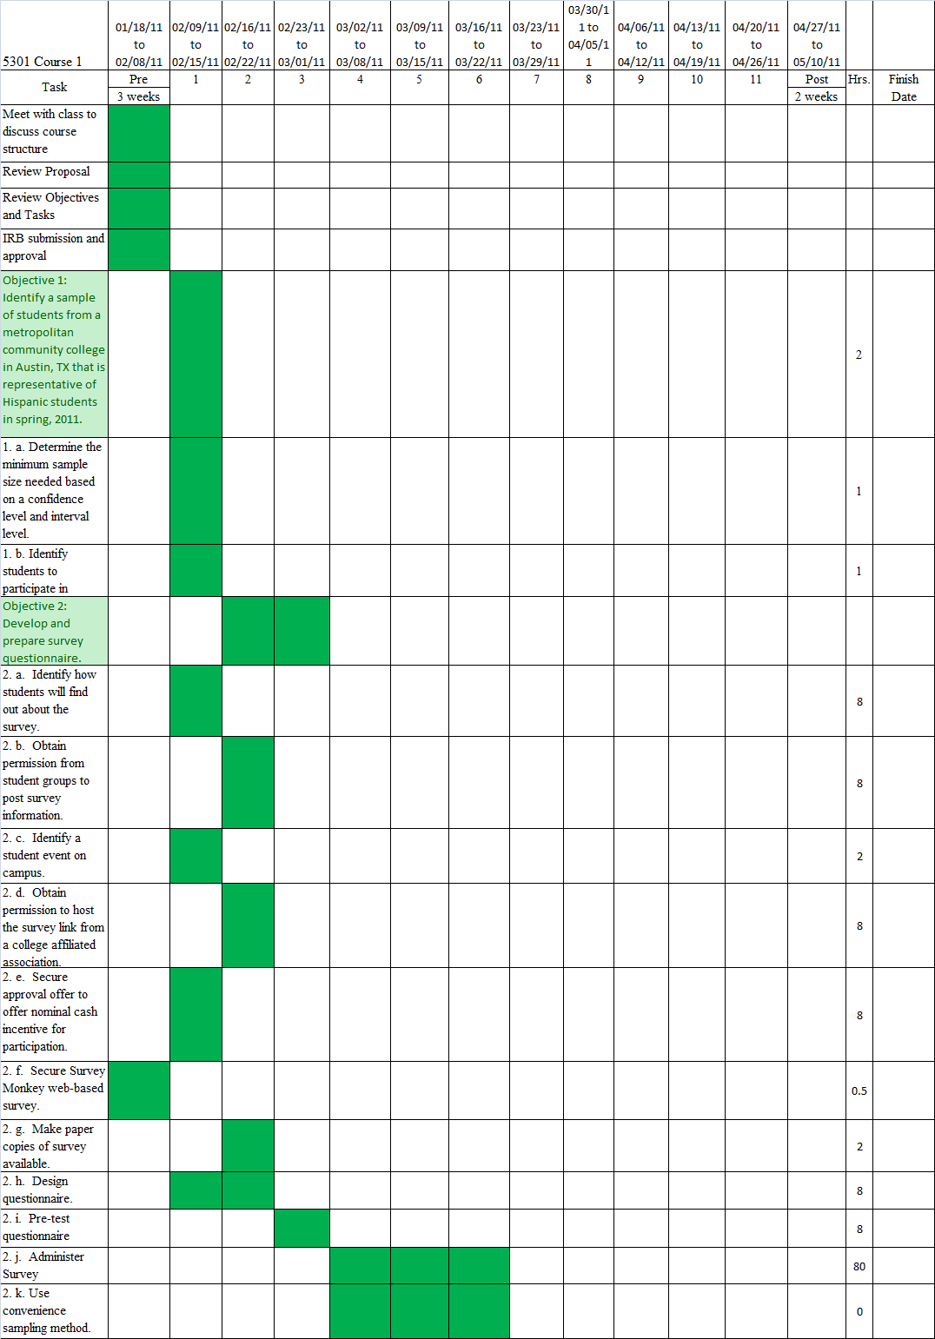

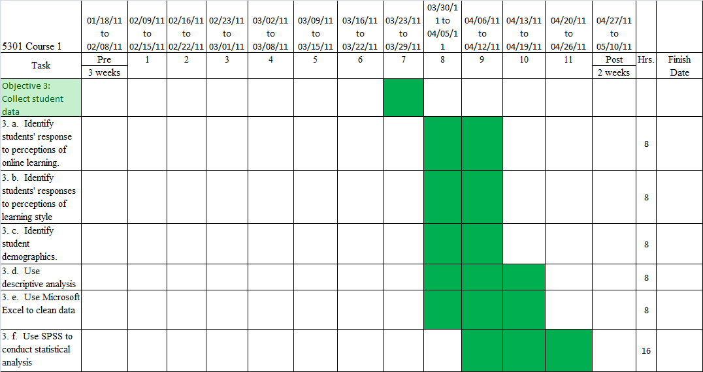

*Procedures for Semester 2* The researcher will analyze data and write final report based on findings from research and data analysis

*Pre-contractual.*

1. Submit IRB request
2. Finalizing contract with instructor
3. Have a clear understanding of study

*Contractual*

4. Analyze data

4. a. Use descriptive analysis

4. b. Identify outliers

4. c. Clean data for consistency

4. d. Identify if questions were all answered.

4. e. Examine data by using univariate analysis

4. f. Solve for distribution

4. g. Calculate central tendency

4. h. Identify dispersion

4. i. Create frequency distribution table

4. j. Identify mean, median, and mode.

4. k. Calculate standard deviation

4. l. Calculate variance by using ANOVA model

4. m. Calculate multiple regression and correlation

4. n. Use The Person r

4. o. Chi-square test of independence

5. Document Research

5. a. State the research problem

5. b. State causal relationship

5. c. State constructs

5. d. Cite literature from scholarly journals and other credible sources.

5. e. State research questions

5. f. Discuss sampling procedures

5. g. Discuss external validity considerations

5. h. Evaluate outcome measures

5. i. Discuss construction measures

5. j. Address reliability and validity

5. k. Write results with tables or figures

.

*Post-contractual*.

1. Attend a graduate forum.
2. Complete formative and summative evaluations.
3. Write final report of research findings.

*Start Date and Duration of Activity.* The following chart indicates the procedure for each week each and an expected start and end time for OCED 5302.

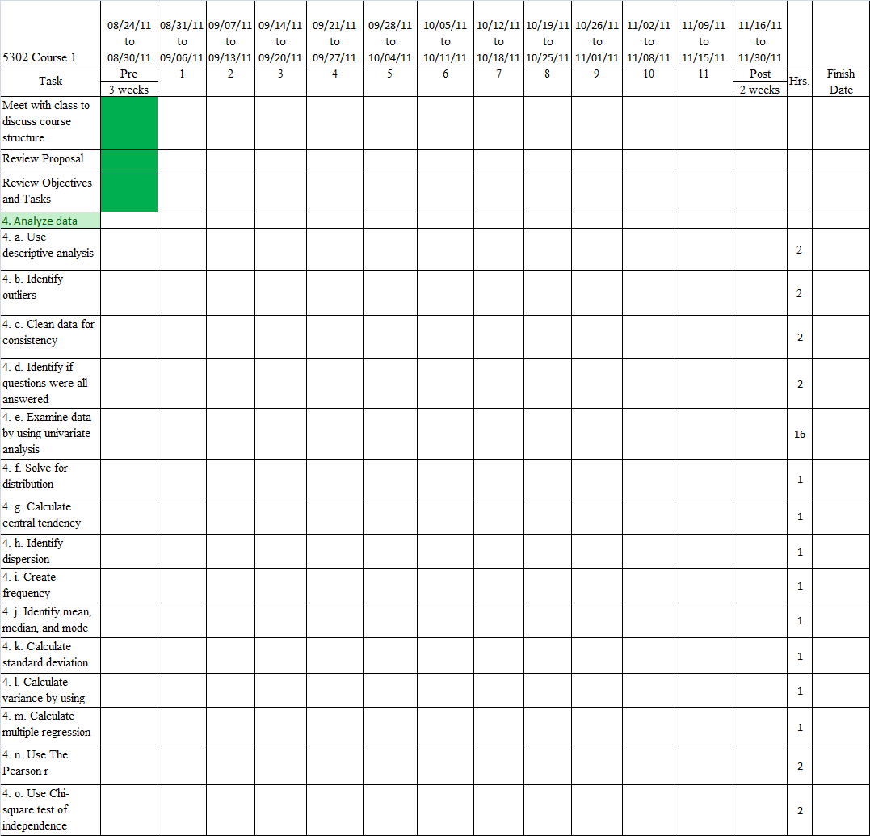

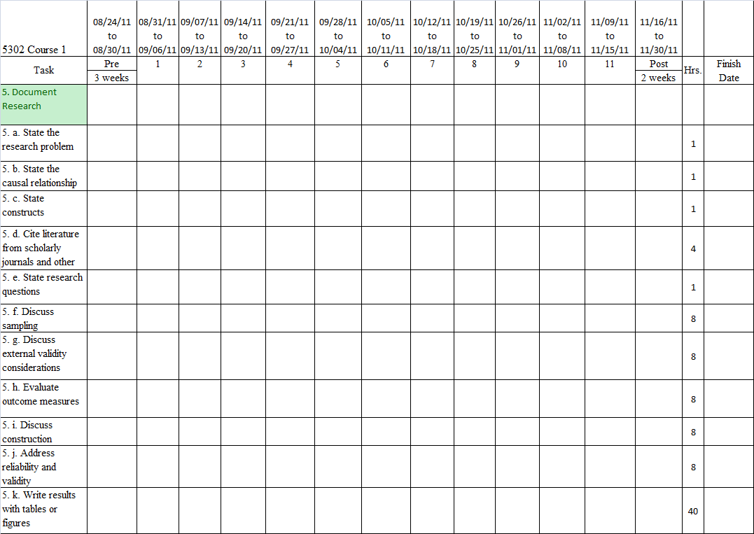

Chapter IV – Research Evaluation Plan

*Formative Evaluation*

The formative evaluation plan will provide a framework that can be used to evaluate intended procedures and outcomes for this study.

*Procedures to be Evaluated*. The researcher will assume evaluative accountability for the following:

1. Identify a sample of students from a metropolitan community college in Austin, TX that is representative of Hispanic students in spring, 2011.

1. a. Determine the minimum sample size needed based on a confidence level and interval level.

1. b. Identify students to participate in survey.

2. Develop and prepare survey questionnaire

2. a. Identify how students will find out about the survey.

2. b. Obtain permission from student groups to post survey information.

2. c. Identify a student event on campus.

2. d. Obtain permission to host the survey link from a college affiliated association.

2. e. Secure approval offer nominal cash incentive for participation.

2. f. Secure survey monkey web-based survey.

2. g. Make paper copies available.

2. h. Design questionnaire

2. i. Pretest questionnaire

2. j. Administer survey

2. k. Use convenience sampling method

3. Collect student data

3. a. Identify students’ response to perceptions of online learning

3. b. Identify students’ responses to perceptions of learning style

3. c. Identify student demographics

3. d. Use categorical analysis

3. e. Use Microsoft Excel to clean data

3. f. Use SPSS to conduct statistical analysis

*Evaluation Parameters (Time and Quality*). The evaluation parameters will include quantitative and qualitative characteristics. The quantitative characteristics will be inclusive of the abstract, introduction, literature review, methodology, results, discussion and conclusion, and reflection on the research process. Qualitative characteristics will consider adherence to APA guidelines with regard to writing the final report.

*Weight.* The weight for the formative and summative evaluations is equally important and shall be weighted at 50% respectively.

*Summative Evaluation*

The summative evaluation will be used as a framework for the identified independent evaluator to evaluate the products herein.

*Products to be Evaluated.*

1. A sampling protocol developed to and administered through a convenience sample to capture responses from Hispanic students at a community college.

2. Prepared and developed a survey questionnaire that would appropriately include questions to discern students’ perceptions of learning styles and perceptions of online courses from Hispanic community college students.

3. Student data was collected from the survey instruments that were developed for this study.

4. Analyzed data using SPSS and Excel to clean data, identify outliers, and administer statistical analysis.

5. Documented research findings of study and includes the appropriate analysis and use of tables and/or graphs.

*Evaluation Parameters*.The evaluation parameters will include quantitative and qualitative characteristics. The quantitative characteristics will be inclusive of the abstract, introduction, literature review, methodology, results, discussion and conclusion, and reflection on the research process. Qualitative characteristics will consider adherence to APA guidelines with regard to writing the final report.

*Weight*. The weight for the formative and summative evaluations is equally important and shall be weighted at 50% respectively.

*Independent Evaluator.* Dr. Stephanie Hawley is the Associate Vice President of College Access Programs at Austin Community College. She provides leadership in developing a comprehensive strategic plan focused on improving student persistence and successful completion of college access courses and programs, transition of students into college credit courses and programs, and increasing equity of student success in all college level courses and programs.

Dr. Hawley is also an independent consultant for Global Solutions, privately held information and technology and services industry, where she provides professional and organizational development seminars and workshops for faculty and K-12 teachers; conducts quantitative and qualitative research regarding underserved populations in higher education; facilitates workshops and seminars for instructors to promote minority student engagement and active learning; and consults on enrollment management and retention initiatives.

Dr. Hawley earned her doctoral degree at the University of Texas at Austin in Higher Education Administration; a master’s of science in education from the University of Houston-Clear Lake, and bachelor’s degree in English composition from the University of North Texas. Publications for Dr. Hawley include, “Leading Academic Change in a Collective Bargaining Environment” (Under Review); Contributing author to “Revitalizing the Movement: Morton’s Momentum” Leadership Abstracts, July 2006, Vol. 19 (7); “Increasing the Effectiveness of Hispanic Serving Institutions: Policies and Practices for Community Colleges”; ” Blue Ribbon Project, Morton College, Cicero, IL, April 2004. S. Hawley, “Measuring Up: Do Tests Help Boost Education?" The Herald, Rock Hill, SC, Spring 1999. S. Hawley, “Choosing a Major,” Career World, 24(6)1996. S. Hawley, and “The SAT/ACT: Does Coaching Work?” Career World, 23(2) 1994.

References

Adam, S. a. (2009). Blended and online learning: student perceptions and performance.  *Technology and Smart Education* *, 6*, pp. 140-155.

Bailey, Thomas R. and Alfonso, Mariana . (2005, January ). *Paths to Persistence* . Retrieved October 2, 2010, from Lumina Foundation : http://www.luminafoundation.org/publications/PathstoPersistence.pdf

Basmat, B. and Lewis, L. (2008). *Distance Education at Degree-Granting Postsecondary Institutions: 2006-2007*. Retrieved October 30, 2010, from National Center for Educaiton Statistics, Institute of Education Services, U.S. Department of Education. Washington, DC.: http://nces.ed.gov/pubs2009/2009044.pdf

Bathe, J. (2001, November 16). Love It, Hate It, or Don't Care: Views on Online Learning . *ERIC Number ED463805)* .

Beebe, R., Vonderwell, S., & and Boboc, M. (2009). Emerging Patterns in Transferring Assessment Practices from F2f to Online Environments. *Electronic Journal of e-Learning* *, 8* (1), pp1-12.

*Creative Research Systems* . (2007-2010). Retrieved November 2010, from The Survey Sample : http://www.surveysystem.com/sscalc.htm

Diaz, D. P. (1999). Comparing Student Learning Styles in an Online Distance Learning Class and an Equivalent On-Campus Class. *College Teaching* *, 47* (4), 130-135.

Diaz, D. P. (2010). *Learning Technology Series* . Retrieved November 2010, from Online Learning Style Inventory : http://home.earthlink.net/~davidpdiaz/LTS/sitepgs/grslss2.htm

Distance Learning, Austin Community College . (2010). *Distance Learning* . Retrieved November 5, 2010, from Austin Community College : http://dl.austincc.edu/

GAO, U.S. General Accounting Office. (2002, September 26). *Distance Education Growth in Distance Education Programs and Implications for Federal Educaiton Policy*. Retrieved October 1, 2010, from United States General Accounting Officer: http://www.gao.gov/new.items/d021125t.pdf

Knowles, M. S., & Holton III, E. F. (1998). *The Adult Learner, The Definitive Classic in Adult Education and Human Resource Development .* Woburn, MA: Butterworth-Heinemann .

OIEA, Office of Institutional Effectiveness and Accountability. (2010, September 8). *Office of Institutional Effectiveness and Accountability*. Retrieved October 10, 2010, from Preliminary Enrollment Reports, High Demand Reports, and Headcount Attrition Summary: http://www.austincc.edu/oiepub/pubs/prenrl/prenrl_fall2010.pdf

R.N. Harris, W. D. (2003). Are learning styles relevant in web-based instruction? . *Journal of Educational Computing Research* *, 29*, 13-38.

Rakap, S. (2010). Impacts of Learning Styles and Computer Skills on Adult Students' Learning Online. *The Turkish Online Journal of Educational Technology* *, 9* (2), 108-115.

Ruey, S. (2010). A case study of constructivist instructional strategies for adult online learning. *The British Journal of Educational Technology* *, 41* (5), 706-720.

Smart, K. L. (2006 ). Students' Perceptions of Online Learning: A Comparative Study . *Journal of Information Technology Education* , pp 201-219.

Smith, P. J. (2005). Learning Preferences and Readiness for Online Learning. *Educational Psychology* *, 25* (1), 3-12.

Stanford-Bowers, D. E. (2008). Persistence in Online Classes: A Study of Perceptions among Community College Stakeholders. *MERLOT Journal of Online Learning and Teaching* *, 4* (1), 37-50.

Terrell, S. a. (1999). An investigation of the effect of learning style on student success in an onilne learning environment. *Journal of Educational Technology Systems* *, 28(3)*, 231-238.

U.S. Department of Education, Office of Planning, Evaluation, and Policy Development: Policy and Program Studies Service. (2009). *Evaluation of Evidence-Based Practices in Online Learning: A Meta-Analysis and Review of Online Learning Studies.* Washington, D.C.: U.S Department of Education.

USDOE, U.S. Department of Education. (2010, February 23). *U.S. Department of Education*. Retrieved October 1, 2010, from Developing Hispanic-Serving Institutions Program Title V: http://www2.ed.gov/programs/idueshsi/definition.html

Wighting, M. J. (2008). Distinguishing Sense of Community and Motivation Characteristics Between Online and Traditional College Students. *The Quarterly Review of Distance Education* *, 9(3)*, 285-295.

Appendix A

|  |  |  |
| --- | --- | --- |
| Table 1 |  |  |
| Learning Style Systems |  |  |
| Researcher | Style Dimensions | Instruments |
| *Cognitive learning style systems* |  |  |
| David Kolb (1984) | Two dimensions (perceptual and processing) proposed: concrete experience vs. abstract generalization, and active experimentation vs. reflective observation. Results in four styles: divergers, assimilators, convergers, and accomodators. | Learning Style Inventory (1984) |
| Bernice McCarthy (1980) | Two dimensions (perceptual and processing) proposed: There are four major learning styles: 1) The Concrete-Random or "Imaginative Learner, 2) The Abstract-Sequential learner wants to know "What" to learn, 3) The Concrete-Sequential learner wants to know "How" to apply the learning, and 4) The Abstract-Random learner asks "If" this is correct how can I modify it to make it work for me. | 4MAT system |
| Anthony F. Gregorc (1984) | Two dimensions (perceptual and processing) proposed: abstract vs. concrete experience, and sequential vs. random ordering of information. Results in four styles, though ranges are allowed: concrete sequential, concrete random, abstract sequential, and abstract random. | Gregorc Learning Style (1984) |
| *Cognitive, Affective, and Physiological Systems* |  |  |
| Dunn and Dunn (1974), Dunn, Dunn and Price (1989) | Assess 20 factors in four groups: environmental, sociological, emotional, and physical preferences. | Learning Style Inventory (1989) (for children) Productivity Environmental Preference Survey (1989) (for adults) |
| Canfield (1988) | Assess 20 factors in four groups: conditions of learning, content of learning, mode of learning, and expectations of learning. | Canfield's Learning Style Inventory |
| *Personality Systems (with implications for learning)* |  |  |
| Briggs and Meyers (1977) | Assess four scales: extraversion vs. introversion; intuition vs. sensing; thinking vs. feeling; and judging vs. perceiving. | Myers-Briggs Type Indicator (MBTI) |
| Costa and McRae (1992) | Assess "big five" personality dimensions: neuroticism, extraversion, openness, agreeableness, conscientiousness. Emerging as a strong research-based approach to personality assessment. | NEO-PI-R |
| Note: Adapted from The Adult Learner, The Definitive Classic in Adult Education and Human Resource Development. | | |

Research Contract I

Texas State University

Student Shari C. Rodriquez

Address 304 Olmos Drive, Leander, TX 78641

Work Phone Number 512-223-1106 Course Number OCED 5300

Title of Proposed Activity

Faculty Advisor Matthew A. Eichler, PhD Agency Texas State University

Address Occupational Education San Marcos, Texas 78666

Work Phone Number

1. GOALS
2. Assist the researcher in translating theory into practice.
3. Develop and refine the research skills of the researcher.

II. OBJECTIVES

The researcher will work cooperatively with the faculty advisor in accomplishing the following objectives:

1. Identify a sample of students from a metropolitan community college in Austin, TX that is representative of Hispanic students in spring, 2011.

2. Develop and prepare survey questionnaire

3. Collect student data

III. PROCEDURES

The research will accomplish the aforementioned objectives by completing the following:

1.

1. a. Determine the minimum sample size needed based on a confidence level and interval level.

1. b. Identify students to participate in survey.

2.

2. a. Identify how students will find out about the survey.

2. b. Obtain permission from student groups to post survey information.

2. c. Identify a student event on campus.

2. d. Obtain permission to host the survey link from a college affiliated association.

2. e. Secure approval offer nominal cash incentive for participation.

2. f. Secure survey monkey web-based survey.

2. g. Make paper copies available.

2. h. Design questionnaire

2. i. Pretest questionnaire

2. j. Administer survey

2. k. Use convenience sampling method

3.

3. a. Identify students’ response to perceptions of online learning

3. b. Identify students’ responses to perceptions of learning style

3. c. Identify student demographics

3. d. Use descriptive analysis

3. e. Use Microsoft Excel to clean data

3. f. Use SPSS to conduct statistical analysis

IV. RESPONSIBILITIES

1. University
2. The faculty advisor will provide supervision and guidance to the researcher.
3. The faculty advisor will provide consultation on problem related to the research.
4. Researcher
5. The researcher will participate in weekly meetings with the faculty advisor.
6. The researcher will assume full responsibility for executing the objectives of the contract.

C. Duration and Hours per Week

Beginning Date 01/18/11 Ending Date 05/10/11

Number of Weeks 16

Total Number of Contractual Hours

Average Hours/Week

V. TERMINATION

By the University:

The faculty advisor reserves the right to terminate the contract upon clear evidence that the research does not contribute to the researcher’s professional competencies, or if the researcher’s personal actions are deemed to be a source of embarrassment to or detrimental to the best interests of the University.

Researcher Date Faculty Advisor Date

Research Contract II

Texas State University

Student Shari C. Rodriquez

Address 304 Olmos Drive, Leander, TX 78641

Work Phone Number 512-223-1106 Course Number OCED 5300

Title of Proposed Activity

Faculty Advisor Matthew A. Eichler, PhD Agency Texas State University

Address Occupational Education San Marcos, Texas 78666

Work Phone Number

I. GOALS

1. Assist the researcher in translating theory into practice.

2. Develop and refine the research skills of the researcher.

II. OBJECTIVES

The researcher will work cooperatively with the faculty advisor in accomplishing the following objectives:

4. Analyze Data

5. Document Research

III. PROCEDURES

The research will accomplish the aforementioned objectives by completing the following:

4.

4. a. Use descriptive analysis

4. b. Identify outliers

4. c. Clean data for consistency

4. d. Identify if questions were all answered.

4. e. Examine data by using univariate analysis

4. f. Solve for distribution

4. g. Calculate central tendency

4. h. Identify dispersion

4. i. Create frequency distribution table

4. j. Identify mean, median, and mode.

4. k. Calculate standard deviation

4. l. Calculate variance by using ANOVA model

4. m. Calculate multiple regression and correlation

4. n. Use The Person r

4. o. Chi-square test of independence

5.

5. a. State the research problem

5. b. State causal relationship

5. c. State constructs

5. d. Cite literature from scholarly journals and other credible sources.

5. e. State research questions

5. f. Discuss sampling procedures

5. g. Discuss external validity considerations

5. h. Evaluate outcome measures

5. i. Discuss construction measures

5. j. Address reliability and validity

5. k. Write results with tables or figures

IV. RESPONSIBILITIES

A. University

1. The faculty advisor will provide supervision and guidance to the researcher.
2. The faculty advisor will provide consultation on problem related to the research.

B. Researcher

1. The researcher will participate in weekly meetings with the faculty advisor.
2. The researcher will assume full responsibility for executing the objectives of the contract.

C. Duration and Hours per Week

Beginning Date 08/24/11 Ending Date 11/30/11

Number of Weeks 16

Total Number of Contractual Hours

Average Hours/Week

V. TERMINATION

By the University:

The faculty advisor reserves the right to terminate the contract upon clear evidence that the research does not contribute to the researcher’s professional competencies, or if the researcher’s personal actions are deemed to be a source of embarrassment to or detrimental to the best interests of the University.

Researcher Date Faculty Advisor Date

**Formative Evaluation Form for Quantity – Semester 1**

Research Name: Hispanic Students Perceptions of Online Learning Courses at a Hispanic Serving Institution Community College

|  |  |  |  |  |
| --- | --- | --- | --- | --- |
| **Week No.** | **Hours/Week** | **Advisor’s Initials & Date** | **Objective No.** | **Procedure No.** |
| Third |  |  |  |  |
| Fourth |  |  |  |  |
| Fifth |  |  |  |  |
| Sixth |  |  |  |  |
| Seventh |  |  |  |  |
| Eighth |  |  |  |  |
| Ninth |  |  |  |  |
| Tenth |  |  |  |  |
| Eleventh |  |  |  |  |
| Twelfth |  |  |  |  |
| Thirteenth |  |  |  |  |
| Fourteenth |  |  |  |  |
| Fifteenth |  |  |  |  |
| TOTAL HOURS EXPENDED |  |  |  |  |

I certify that the above information is accurate.

Signature of Faculty Advisor: Date:

/ =

Hours Contracted

Expended Hours

## FOR OFFICE USE ONLY

Formative Evaluation Form for Quality – Semester 1

Student: Shari Carrasco Rodriquez

Please evaluate the researcher’s performance on the following specific duties and check the box that best describes their performance.

|  |  |  |  |  |  |
| --- | --- | --- | --- | --- | --- |
| Specific procedural statements performed by the researcher: | Unsat. 20 pts. | Poor  40 pts. | Average  60 pts. | Good  80 pts. | Superior  100 pts. |
| 1. Identify a sample of students from a metropolitan community college in Austin, TX that is representative of Hispanic students in spring, 2011.   1. a. Determine the minimum sample size needed based on a confidence level and interval level.  1. b. Identify students to participate in survey.   1. Develop and prepare survey questionnaire   2. a. Identify how students will find out about the survey.  2. b. Obtain permission from student groups to post survey information.  2. c. Identify a student event on campus.  2. d. Obtain permission to host the survey link from a college affiliated association.  2. e. Secure approval offer nominal cash incentive for participation.  2. f. Secure survey monkey web-based survey.  2. g. Make paper copies available. 9  2. h. Design questionnaire  2. i. Pretest questionnaire  2. j. Administer survey  2. k. Use convenience sampling method   1. Collect student data   3. a. Identify students’ response to perceptions of online learning  3. b. Identify students’ responses to perceptions of learning style  3. c. Identify student demographics  3. d. Use descriptive analysis  3. e. Use Microsoft Excel to clean data  3. f. Use SPSS to conduct statistical analysis |  |  |  |  |  |

/ =

### Total Points No. of Procedural

Sentences

**FOR OFFICIAL USE ONLY**

Please identify areas that need to be improved.

Please make any general comments that you feel are appropriate.

Signature of Faculty Advisor Date

**Formative Evaluation Form for Quantity – Semester 2**

Research Name: Hispanic Students Perceptions of Online Learning Courses at a Hispanic Serving Institution Community College

|  |  |  |  |  |
| --- | --- | --- | --- | --- |
| **Week No.** | **Hours/Week** | **Advisor’s Initials & Date** | **Objective No.** | **Procedure No.** |
| Third |  |  |  |  |
| Fourth |  |  |  |  |
| Fifth |  |  |  |  |
| Sixth |  |  |  |  |
| Seventh |  |  |  |  |
| Eighth |  |  |  |  |
| Ninth |  |  |  |  |
| Tenth |  |  |  |  |
| Eleventh |  |  |  |  |
| Twelfth |  |  |  |  |
| Thirteenth |  |  |  |  |
| Fourteenth |  |  |  |  |
| Fifteenth |  |  |  |  |
| TOTAL HOURS EXPENDED |  |  |  |  |

I certify that the above information is accurate.

Signature of Faculty Advisor: Date:

/ =

Hours Contracted

Expended Hours

## FOR OFFICE USE ONLY

Formative Evaluation Form for Quality – Semester 2

Student Shari Carrasco Rodriquez

Please evaluate the researcher’s performance on the following specific duties and check the box that best describes their performance.

|  |  |  |  |  |  |
| --- | --- | --- | --- | --- | --- |
| Specific procedural statements performed by the researcher: | Unsat. 20 pts. | Poor  40 pts. | Average  60 pts. | Good  80 pts. | Superior  100 pts. |
| 4. Analyze data  4. a. Use descriptive analysis  4. b. Identify outliers  4. c. Clean data for consistency  4. d. Identify if questions were all answered.  4. e. Examine data by using univariate analysis  4. f. Solve for distribution  4. g. Calculate central tendency  4. h. Identify dispersion  4. i. Create frequency distribution table  4. j. Identify mean, median, and mode.  4. k. Calculate standard deviation  4. l. Calculate variance by using ANOVA model  4. m. Calculate multiple regression and correlation  4. n. Use The Person r  4. o. Chi-square test of independence  5. Document Research  5. a. State the research problem  5. b. State causal relationship  5. c. State constructs  5. d. Cite literature from scholarly journals and other credible sources.  5. e. State research questions  5. f. Discuss sampling procedures  5. g. Discuss external validity considerations  5. h. Evaluate outcome measures  5. i. Discuss construction measures  5. j. Address reliability and validity  5. k. Write results with tables or figures |  |  |  |  |  |

/ =

### Total Points No. of Procedural

Sentences

**FOR OFFICIAL USE ONLY**

Please identify areas that need to be improved.

Please make any general comments that you feel are appropriate.

Signature of Faculty Advisor Date

Summative Evaluation Form I

Name: Shari Carrasco Rodriquez

Product Description:

A sampling protocol developed to and administered through a convenience sample to capture responses from Hispanic students at a community college.

Quantitative Characteristic(s)

1. (Place your evaluation stem here) Example: *Did the final report contain the required 7 chapter (Abstract, Introduction, Review of the Literature, Methodology, Results, Discussion and Conclusion, and Reflection on the Research Process).*

|  |  |  |  |  |
| --- | --- | --- | --- | --- |
| Number of Chapters  3 | 4 | 5 | 6 | 7 |
| Points:  60 | 70 | 80 | 90 | 100 |

Qualitative Characteristic(s)

2. (Place your evaluation stem here) Example: *On a scale from 1 to 5 with 5 being the highest, how consistently did the final report adhere to APA guidelines?*

|  |  |  |  |  |
| --- | --- | --- | --- | --- |
| Not Consistent |  |  |  | Very Consistent |
| 1 | 2 | 3 | 4 | 5 |
| Points:  60 | 70 | 80 | 90 | 100 |

Independent Evaluator Date

Summative Evaluation Form II

Name: Shari Carrasco Rodriquez

Product Description:

Prepared and developed a survey questionnaire that would appropriately include questions to discern students’ perceptions of learning styles and perceptions of online courses from Hispanic community college students.

Quantitative Characteristic(s)

1. (Place your evaluation stem here) Example: *Did the final report contain the required 7 chapter (Abstract, Introduction, Review of the Literature, Methodology, Results, Discussion and Conclusion, and Reflection on the Research Process).*

|  |  |  |  |  |
| --- | --- | --- | --- | --- |
| Number of Chapters  3 | 4 | 5 | 6 | 7 |
| Points:  60 | 70 | 80 | 90 | 100 |

Qualitative Characteristic(s)

2. (Place your evaluation stem here) Example: *On a scale from 1 to 5 with 5 being the highest, how consistently did the final report adhere to APA guidelines?*

|  |  |  |  |  |
| --- | --- | --- | --- | --- |
| Not Consistent |  |  |  | Very Consistent |
| 1 | 2 | 3 | 4 | 5 |
| Points:  60 | 70 | 80 | 90 | 100 |

Independent Evaluator Date

Summative Evaluation Form III

Name: Shari Carrasco Rodriquez

Product Description:

Student data was collected from the survey instruments that were developed for this study.

Quantitative Characteristic(s)

1. (Place your evaluation stem here) Example: *Did the final report contain the required 7 chapter (Abstract, Introduction, Review of the Literature, Methodology, Results, Discussion and Conclusion, and Reflection on the Research Process).*

|  |  |  |  |  |
| --- | --- | --- | --- | --- |
| Number of Chapters  3 | 4 | 5 | 6 | 7 |
| Points:  60 | 70 | 80 | 90 | 100 |

Qualitative Characteristic(s)

2. (Place your evaluation stem here) Example: *On a scale from 1 to 5 with 5 being the highest, how consistently did the final report adhere to APA guidelines?*

|  |  |  |  |  |
| --- | --- | --- | --- | --- |
| Not Consistent |  |  |  | Very Consistent |
| 1 | 2 | 3 | 4 | 5 |
| Points:  60 | 70 | 80 | 90 | 100 |

Independent Evaluator Date

Summative Evaluation Form IV

Name: Shari Carrasco Rodriquez

Product Description

Analyzed data using SPSS and Excel to clean data, identify outliers, and administer statistical analysis.

Quantitative Characteristic(s)

1. (Place your evaluation stem here) Example: *Did the final report contain the required 7 chapter (Abstract, Introduction, Review of the Literature, Methodology, Results, Discussion and Conclusion, and Reflection on the Research Process).*

|  |  |  |  |  |
| --- | --- | --- | --- | --- |
| Number of Chapters  3 | 4 | 5 | 6 | 7 |
| Points:  60 | 70 | 80 | 90 | 100 |

Qualitative Characteristic(s)

2. (Place your evaluation stem here) Example: *On a scale from 1 to 5 with 5 being the highest, how consistently did the final report adhere to APA guidelines?*

|  |  |  |  |  |
| --- | --- | --- | --- | --- |
| Not Consistent |  |  |  | Very Consistent |
| 1 | 2 | 3 | 4 | 5 |
| Points:  60 | 70 | 80 | 90 | 100 |

Independent Evaluator Date

Summative Evaluation Form V

Name: Shari Carrasco Rodriquez

Product Description:

Documented research findings of study and includes the appropriate analysis and use of tables and/or graphs.

Quantitative Characteristic(s)

1. (Place your evaluation stem here) Example: *Did the final report contain the required 7 chapter (Abstract, Introduction, Review of the Literature, Methodology, Results, Discussion and Conclusion, and Reflection on the Research Process).*

|  |  |  |  |  |
| --- | --- | --- | --- | --- |
| Number of Chapters  3 | 4 | 5 | 6 | 7 |
| Points:  60 | 70 | 80 | 90 | 100 |

Qualitative Characteristic(s)

2. (Place your evaluation stem here) Example: *On a scale from 1 to 5 with 5 being the highest, how consistently did the final report adhere to APA guidelines?*

|  |  |  |  |  |
| --- | --- | --- | --- | --- |
| Not Consistent |  |  |  | Very Consistent |
| 1 | 2 | 3 | 4 | 5 |
| Points:  60 | 70 | 80 | 90 | 100 |

Independent Evaluator Date

Instrument

|  |  |  |  |  |  |  |  |
| --- | --- | --- | --- | --- | --- | --- | --- |
|  | |  | | --- | |  | | | | |  |  |
|  |  |  |  |  |  |  |
|  | **Instructions:** |  |  |  |  |  |
|  | This is a checklist to find out more about you. Some of the sentences describe you better than others. Read each sentence and indicate how much it is like you by marking the appropriate box that best describes you. | | | | |  |
|  |  |
| **1** | **What is your gender?** | Male | Female |  |  |  |
| **2** | **How old are you?** | 18-21 | 22-24 | 25-44 | 45 or older |  |
| **3** | **Are you an international student or foreign national?** | | |  | Yes | No |
| **4** | **Did you enroll in college immediately after graduating from high school?** | | | | Yes | No |
| **5** | **Which of the following have you done, are you doing, or do you plan to do while attending Austin Community College?** | | | | |  |
|  | Developmental reading course | Developmental math course | Developmental writing course | Study skills course | Academic Advising/Planning | Honors program |
| **6** | **How many TOTAL credit hours have you earned at Austin Community College, not counting the courses you are currently taking from this term?** | | | | |  |
|  | None | 1- 14 credits | 15-29 credits | 30-44 credits | 45-60 credits | over 60 credits |
|  |  |  |  |  |  |  |
| **7** | **What is your enrollment status?** | | Full-time (12 credits or more) | Part-time (less than 12 credits) |  |  |
| **8** | **At Austin Community College, in what range is your overall grade average?** | | | | |  |
|  | 3.0 - 4.0 | 2.0- 2.99 | below 2.0 |  |  |  |
| **9** | **What is the highest academic credential you have earned?** | | | |  |  |
|  | None | GED or other High School Equivalent | High School Diploma | Vocational/Technical Certificate | Associate Degree | Bachelor's Degree |
|  | Master's/ Doctoral/Professional Degree |  |  |  |  |  |
|  |  |  |  |  | Choose only one from both columns if known. | |
| **10** | **What is the highest level of education obtained by your:** | | |  | **Mother** | **Father** |
|  |  |  |  | |  | | --- | |  | | 8th grade or less | 8th grade or less |
| **11** | **Are you employed?** | Yes | No |  | Some high school | Some high school |
|  |  |  |  |  | High School or GED | High School or GED |
| **12** | **If yes, how many hours do you work each week?** | | |  | Some Community College | Some Community College |
|  | 1 to 5 | 6 to 10 | 11 to 20 |  | Certificate | Certificate |
|  | 21 to 30 | more than 30 |  |  | Associate degree | Associate degree |
|  |  |  |  |  | Some four-year college | Some four-year college |
| **13** | **Do you have children or dependents living with you at home?** | | | | Bachelor's degree | Bachelor's degree |
|  | Yes | No |  |  | Master's degree | Master's degree |
|  |  |  |  |  | Doctorate degree | Doctorate degree |
|  |  |  |  |  | Unknown | Unknown |
| **14** | **What category describes you best?** | | |  |  |  |
|  | Black (non-Hispanic) | White (non-Hispanic) | Hispanic | Asian or Pacific Islander | American Indian or Native Alaskan | Other (please specify) |
| **15** | **To what extent is the cost of attending Austin Community College an issue for you?** | | | | |  |
|  | not an issue | somewhat of an issue | a significant issue |  |  |  |
| **16** | **Which of the following do you use to pay your tuition at Austin Community College? (Mark all that apply)** | | | | | |
|  | My own income or savings | Spouse/significant other's income or savings | Parent (s) | Employer's contributions | Grants and scholarships | Student loans (bank, etc.) |
|  | Public assistance | Other |  |  |  |  |
| **17** | **Would you consider enrolling in an online course at ACC?** | | | | Yes | No |
| **188** | **If NO, what would prevent you from enrolling** | | |  |  |  |
|  |  |  |  |  |  |  |
|  |  |  |  |  |  |  |

|  |  |  |  |  |  |  |  |  |  |
| --- | --- | --- | --- | --- | --- | --- | --- | --- | --- |
| Questions (SAMPLE) | |  |  |  | |  | |  | |
| This is a checklist to find out more about you. Some of the sentences describe you better than others. Read each sentence and indicate how much it is like you by marking the appropriate box that best describes you. | | | | | |  | |  | |
|  | |  | |
|  | |  | |
|  |  |  |  |  | |  | |  | |
|  |  | Strongly Agree | Agree | | Undecided | | Disagree | | Strongly Disagree | |
| 1 | **I enjoy learning on my own** |  |  |  | |  | |  | |
| 2 | **I would rather learn from traditional face-to-face instruction** |  |  |  | |  | |  | |
| 3 | **Online learning offers flexibility that fits my schedule** |  |  |  | |  | |  | |
| 4 | **I would rather learn from traditional face-to-face instruction** |  |  |  | |  | |  | |
| 5 | **I would be successful in an online learning class if the professor responded sooner rather than later** |  |  |  | |  | |  | |
| 6 | **I enjoy having close friendships** |  |  |  | |  | |  | |
| 7 | **I learn best by doing** |  |  |  | |  | |  | |
| 8 | **I learn best by hearing** |  |  |  | |  | |  | |
| 9 | **I learn best by seeing something** |  |  |  | |  | |  | |
| 10 | **I learn best by hands on experience** |  |  |  | |  | |  | |
| 11 | **I would be successful in an online class if tutoring was available online** |  |  |  | |  | |  | |
| 12 | **I would most likely do my online coursework from (what hours of the day)** |  |  |  | |  | |  | |
| 13 | **I would be successful in an online learning community (define)** |  |  |  | |  | |  | |

Agency Approval

|  |  |
| --- | --- |
| |  | | --- | | **CITI Collaborative Institutional Training Initiative (CITI)** | |
| |  |  | | --- | --- | | **Graduate (NSF) Curriculum Completion Report** | | | **Printed on 9/18/2010** | | |  | | | **Learner:** Shari Rodriquez (username: scrodriquez1) | | | **Institution:** Texas State University - San Marcos | | | **Contact Information** | 304 Olmos Drive 304 Olmos Drive Leander, TX 78641  Department: Occupational Education Phone: 512-947-0617 Email: SR1394@txstate.edu |  |  |  |  |  |  |  |  |  |  |  |  |  |  |  |  |  |  |  |  |  |  |  |  |  |  |  |  |  |  |  |  |  |  |  |  |  |  |  |  |  |  |  |  |  |  |  |  |  |  | | --- | --- | --- | --- | --- | --- | --- | --- | --- | --- | --- | --- | --- | --- | --- | --- | --- | --- | --- | --- | --- | --- | --- | --- | --- | --- | --- | --- | --- | --- | --- | --- | --- | --- | --- | --- | --- | --- | --- | --- | --- | --- | --- | --- | --- | --- | --- | --- | --- | |  | **Graduate (NSF):**   **Stage 1. Basic Course Passed on 09/18/10** (Ref # 4919825)   |  |  | | --- | --- | | **Required Modules** | **Date Completed** | | Introduction to the Responsible Conduct of Research | 09/17/10 | no quiz | | Research Misconduct 2-1495 | 09/18/10 | 4/5 (80%) | | Data Acquisition, Management, Sharing and Ownership 2-1523 | 09/18/10 | 4/5 (80%) | | Publication Practices and Responsible Authorship 2-1518 | 09/18/10 | 4/5 (80%) | | Peer Review 1-1368 | 09/18/10 | 5/5 (100%) | | Introduction to Mentoring | 09/18/10 | no quiz | | Animal Welfare 13301 | 09/18/10 | 6/8 (75%) | | Conflicts of Interest and Commitment 1-1622 | 09/18/10 | 6/6 (100%) | | Collaborative Research 1-1450 | 09/18/10 | 5/6 (83%) | | Human Subjects 13566 | 09/18/10 | 11/11 (100%) | | The CITI RCR Course Completion Page. | 09/18/10 | no quiz | | **Elective Modules** | **Date Completed** |  | | Case Study - Truth or Consequences 2-1217 | 09/18/10 | 3/3 (100%) | | Case Study - In the Field, No One Will Know 2-1218 | 09/18/10 | 3/3 (100%) | | Case Study Plagiarism 2-1472 | 09/18/10 | 2/2 (100%) |   **For this Completion Report to be valid, the learner listed above must be affiliated with a CITI participating institution. Falsified information and unauthorized use of the CITI course site is unethical, and may be considered scientific misconduct by your institution.**  Paul Braunschweiger Ph.D. Professor, University of Miami Director Office of Research Education CITI Course Coordinator | |

##### **Proposal Evaluation**

|  |  |  |  |  |  |
| --- | --- | --- | --- | --- | --- |
| **Characteristic** | **Unsatisfactory**  **20 pts.** | **Poor**  **40 pts.** | **Average**  **60 pts.** | **Good**  **80 pts.** | **Superior**  **100 pts.** |
| 1. How well is the research problem stated? |  |  |  |  |  |
| 2. Is the research purpose clearly stated? |  |  |  |  |  |
| 3. Are the research objectives formatted correctly? |  |  |  |  |  |
| 4. Do the assumptions and limitations seem to addresses consequences associated with the proposed research? |  |  |  |  |  |
| 5. Does the review of the literature provide a reasonable theoretical argument for conducting the research? |  |  |  |  |  |
| 6. Is the review of the literature well organized? |  |  |  |  |  |
| 7. Do the research questions align with the purpose of the research and the review of the literature? |  |  |  |  |  |
| 8. How appropriate is the scope and sequence of the procedures for the research? |  |  |  |  |  |
| 9. Is the formative evaluation model adequately described? |  |  |  |  |  |
| 10. Does the summative evaluation model identify products, standards, and the product evaluation forms? |  |  |  |  |  |
| 11. How clearly is the proposal written and presented overall? |  |  |  |  |  |
| 12. Is the proposal consistent with APA guidelines? |  |  |  |  |  |

Total points / 12 =

Researcher’s Signature